Dynamic Host Configuration Protocol (DHCP)
Introduction
So far you’ve learned that in a client-server network model, the clients and the server communicate with each other to exchange information and services. But you also learned that in order for devices to communicate on the network, devices need IP address configuration. So, client-server networks will not be possible without IP address assignment too and that is the focus of this reading.
Remember, there are two ways devices can be addressed on a network and that is by static or dynamic IP address assignment. Static configuration requires that you manually set up IPv4 configuration on network devices. On the other hand, Dynamic Host Configuration Protocol (DHCP) automatically assigns IP addresses and other network configuration settings to devices on a network.
Since a client-server network already includes a server, it uses DHCP instead of static configuration. In this reading, you will explore the communication process between the client and server in terms of the lease process and IP address renewal process.
How Does DHCP Work?
When a device connects to a network, it sends a request for an IP address to the DHCP server. The DHCP server then assigns an available IP address to the device, along with other network configuration settings such as:
- Subnet mask
- Default gateway
- DNS server addresses
DHCP uses a process called leasing to assign IP addresses. When a device needs IP addresses and sends the request to the DHC server, the server assigns an address to it from the available pool of IP addresses. Additionally, the server then assigns a lease time to the IP address which is the amount of time the device can use the IP address before it needs to be renewed.
When the lease time expires, the device must renew the IP address by requesting a new lease from the DHCP server. If the IP address is still available, the server will renew the lease and extend the lease time. If the IP address is no longer available, the server will assign a new IP address to the device.
Let’s review the steps involved in DHCP IP assignment and renewal process in detail.
DHCP IP assignment steps
DHCP Discover: This step is like a device shouting, "Hello, is there anyone out there who can give me an IP address?" The device sends out a broadcast message called DHCP Discover, which is intended to find any available DHCP servers on the network. This message includes some details about the device, such as its MAC address and hostname. It's like the device is introducing itself to the network, saying "Hey, I'm new here, and I need an IP address to start working properly." A MAC address is a unique identifier for every device that connects to a network. It's shown as a series of 12 characters that include numbers (0-9) and letters (A-F or a-f). These characters are often grouped into pairs and separated by colons (:) or dashes (-). For example, the MAC address 02A4C67890BD can be written as 02:a4:c6:78:90:bd or 02-A4-C6-78-90-BD.
DHCP Offer: When a DHCP server receives the DHCP Discover message, it sends out a reply, "Yes, I can help you out! Here's an IP address you can use." This reply is called DHCP Offer, and it includes an available IP address that the server can assign to the device. It's like a shop assistant telling you, "Yes, we have that item in stock, and it's available for you."
DHCP Request: After receiving the DHCP Offer, the device is excited and says, "Yes, I want that IP address, please!" The device then sends a DHCP Request message to the DHCP server, requesting the IP address that was offered. It's like a customer answering the shop assistant saying “Yes, I want that product, please!"
DHCP Acknowledgment: Finally, the DHCP server replies to the device's request with a DHCP Acknowledgment message, which is like saying, "Sure, that IP address is yours, and here are some additional details you need to know." The acknowledgment message confirms the assignment of the IP address to the device and provides the additional configuration information. It's like the shop assistant handing the product over to the customer and saying, "Here's your purchase, and here are the batteries you need to make it work." The image below demonstrates the steps of the DHCP IP assignment process as discussed above.
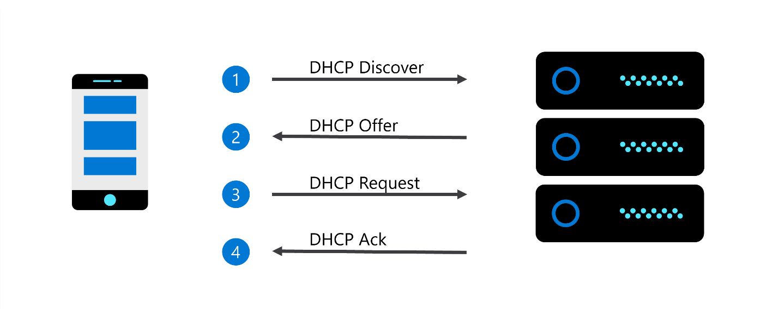
But, this IP address will only be valid for a limited time, therefore there is also a DHCP IP renewal process that involves more steps. Let’s explore them.
DHCP IP renewal process
DHCP Lease Time: When a device gets an IP address from a DHCP server, the server also assigns a lease time to that address. The lease time is like a permission slip that says the device can use the IP address for a certain period. Think of it like successfully borrowing a book from the library for some time.
DHCP Renewal: As the lease time nears its end, the device starts to get nervous and wonders, "What will happen when my lease is up? Will I lose my IP address?" To avoid losing the IP address, the device sends a DHCP Renewal request to the DHCP server. It's like asking the librarian, "Can I borrow the book for another while, please?"
DHCP Server Response: The DHCP server receives the DHCP Renewal request and checks if the IP address is still available. If the IP address is still free, the server sends a DHCP Acknowledgment message that renews the lease time for the device. It's like the librarian saying, "Sure, you can borrow this book for another while, have fun reading!"
DHCP Address Release: If the device doesn't renew the lease, or the DHCP server doesn't respond to the renewal request, the lease time expires. The IP address is then released back to the pool of available addresses. It's like the librarian saying, "Sorry, you have kept the book in your possession for enough time, it's time to return it to the library."
The image below demonstrates the IP renewal process discussed above.
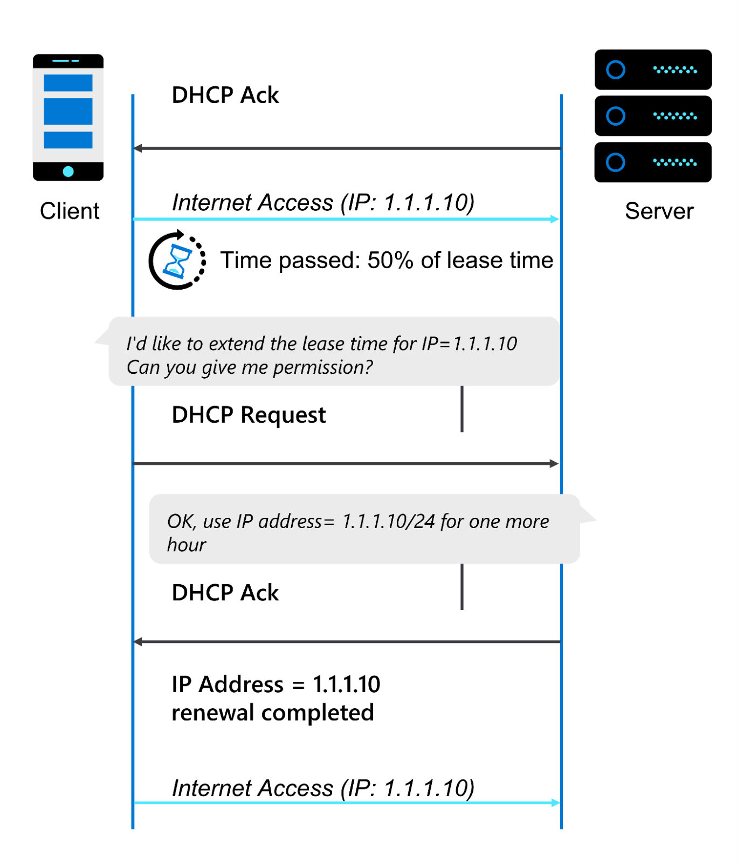
Advantages and disadvantages of the DHCP system
There are several advantages of DHCP. Its automated process simplifies network configuration, reduces administrative overhead and configuration errors, especially for large networks. But there are also some disadvantages of DHCP because it relies on a single DHCP server to manage the assignment of IP addresses and other configuration information. If the DHCP server goes down, devices on the network may not be able to obtain IP addresses or connect to the network. DHCP can also introduce security risks if not configured properly. For example, rogue DHCP servers can be used to assign IP addresses and other configuration information to devices on the network, potentially exposing sensitive data to attackers.
DHCP Relay
Imagine you're a device that needs an IP address, but you're not directly connected to a DHCP server. Instead, you're connected to a switch that's connected to another switch, and that switch is finally connected to the DHCP server. What do you do?
Well, that's where a DHCP relay agent comes in. It is like having a messenger bird that flies between you and the DHCP server to deliver your message. A DHCP Relay Agent is a special program that's installed on the switches. It intercepts and forwards DHCP messages between devices on other subnets and the DHCP server.
Conclusion
In this reading, you discovered how a client-server model works with DHCP IP assignment. You’ve explored the DHCP IP assignment and renewal process in more detail. And you’ve also learned about DHCP relay agents and some advantages and disadvantages of DHCP.

